Te hua o tō tātou taupori kaumātuatanga ki ngā anamata whanake whare, tāone anō hoki
The long-term implications of our ageing population for our housing and urban futures
G.74

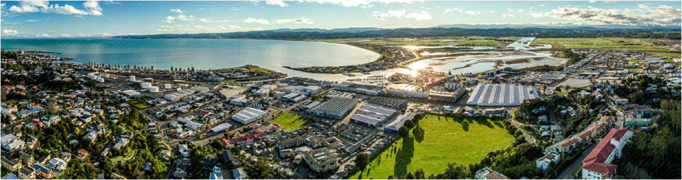

Long-term Insights Briefing
March 2023

Whakarāpopototanga

Executive summary

Presented to the House of Representatives pursuant to Section 8 of the Public Service Act 2020.
Long-term Insights Briefings (Briefings) are a new requirement under Schedule 6 of the Public Service Act 2020. They provide the public with information about medium and long-term trends, risks, and opportunities affecting Aotearoa New Zealand at least 10 years in the future, and options for how we might respond.
Our Briefing considers the implications of our ageing population for our housing and urban futures.
Population ageing will increase the number of people aged 65 years and older and change the composition of our population. We consider this in the context of existing conditions in Aotearoa New Zealand and what that means for likely futures across three domains:

- Housing tenure and housing costs
- Our houses and our housing stock
- Neighbourhoods, towns, and cities.
Across these three domains, we've identified four key shifts needed for our housing and urban development system to support the needs of an ageing population across their life stages and into older age:

- More affordable housing. This provides people stability to participate in education, employment, and in their communities.
- Diversified tenure choices beyond renting and owner occupation to alternative tenures. This improves tenure security, ensures housing costs are
manageable, and sustains living standards to support wellbeing.
- Increased diversity and functionality of the housing stock. This is required to allow people to live as independently as possible.
- Neighbourhoods, towns, and cities that are designed to make it easy for people to access the amenities they need to support their wellbeing.
The likely impacts of our ageing population for our housing and urban futures reinforces the need for change, to ensure Aotearoa New Zealand has the homes and communities people need. There is no silver bullet to achieve these shifts. While there is work
underway, a sustained and collaborative effort by central and local government, iwi and Māori, and the private and not-for-profit sector, will be needed to ensure that our places develop in ways that best meet the needs of our aging population.

Rārangi Upoko

Contents

Executive summary 3
- Introduction 5
- What does our ageing population look like? 8
  - What is population ageing? 8
  - Ethnic diversity and population ageing 9
  - Regions and population ageing 11
  - Population ageing, size, and movement 12
- Ageing populations and housing and urban futures 13
  - Housing tenure and housing costs 13
  - Our houses and our housing stock 19
  - Neighbourhoods, towns, and cities 23
- Meeting the challenge – we need a multi-faceted response 28
- Submissions on the Briefing consultation document 30
Acknowledgements 32
Disclaimer 33
Selected references 34

Kupu Whakataki Introduction
1.

There are few things more important to people and whānau than the homes and communities they live in. Well-performing housing and urban systems are critical for Aotearoa New Zealand’s social, economic, and environmental performance, and the adaptability of our communities.
Te Tūāpapa Kura Kāinga – Ministry of Housing and Urban Development (HUD) has a system leadership role in promoting the longer-term transformation of our housing and urban systems to ensure people and communities flourish. As well as working alongside others to improve housing outcomes, we have a role in identifying upcoming system risks and challenges. These need to be considered as we support the development of more effective and adaptable housing and urban systems that meet the needs of Aotearoa New Zealand.
We have adopted two important frameworks to guide our system leadership role: Te Maihi o te Whare Māori – the Māori and Iwi Housing and Innovation (MAIHI) Framework for Action and a place-based approach.
The MAIHI Framework recognises that Māori are disproportionately impacted by the housing crisis and long-term housing disparities. Consistent with Te Tiriti o Waitangi, MAIHI recognises that Māori are at the heart of our Aotearoa housing approach using a
framework and strategy to change the housing system, so it delivers better solutions by Māori for Māori. MAIHI

Ka Ora – The National Māori Housing Strategy and implementation plan, and our MAIHI partnerships programme support this approach.
Our place-based approach uses an understanding of places to inform how we work with communities. This includes partnerships with communities to help support Māori-led solutions, supports people at risk of
or experiencing homelessness, better planning, liveable and resilient cities, investment in infrastructure, and more affordable homes.
The impacts of an ageing population on our housing and urban systems are likely to be profound and persistent. Our Briefing provides an opportunity to reflect on the futures of Aotearoa New Zealand’s housing and urban systems through the particular lens of our ageing population.

Population ageing is not simply a matter of dealing with a bubble of baby boomers that eventually ebb away and a young population re- emerges.
Population ageing will increase the number of people
aged 65 years and older (seniors), as well as change the composition of our population.

Population ageing impacts young and old
The housing conditions that children and young people experience heavily influence their life trajectories and housing into their senior years. Similarly, the housing wealth of seniors influences the housing of following generations.

Everyone benefits from housing and places that support positive ageing
Older people contribute to their communities, the economy, and families and whānau through knowledge and experience, paid and unpaid work, as carers, through paying tax and through their expenditures. Our housing and urban systems are critical to supporting seniors to continue contributing to their communities.
We can do this by providing safe, secure, functional, and affordable housing, and urban environments that support social connection and wellbeing.

Housing fairness is important
Housing and urban systems that enable people to meet their fundamental need for shelter and a home are predicated on housing fairness. That is, ensuring that housing and urban systems protect people from housing exclusion, and do not present direct and indirect barriers to finding decent housing solutions.
Failures in housing fairness are evident in the over representation of marginalised populations. These include Māori and Pacific peoples, women, young people, disabled people, and people on very low incomes. These populations are vulnerable to experiences of homelessness, severe housing stress, overcrowding, and precarious housing. They are
also more likely to live in poorly performing and poor condition dwellings.
These burdens have been evident for decades. Addressing the challenges of an ageing population provides an opportunity to promote housing fairness to people of all ages.

Housing and urban systems
Our housing and urban systems are large and complex, with many different moving parts and contributors.
These include central and local government, iwi and Māori, a range of private housing providers and property investors, and Community Housing Providers (CHPs).
Our towns and cities are shaped by decisions around transport and infrastructure. Building new homes in cities, towns, and rural areas, depends on the building and construction sector, and finance sector.
Housing needs and peoples' ability to find and sustain access to decent housing is affected by, and can impact on, our social services, income support, education, and health systems. These interconnected systems create the communities that we live in.
These systems also encompass the connections that drive prosperity and wellbeing. That includes the
connections people have to their homes, friends, and communities,
that whānau have to their whakapapa and their whenua, as well as how people access jobs, training opportunities, goods and services, green spaces, and the opportunities they provide.

Our housing and urban systems are beginning to operate in different ways and produce different results:

- Government and the building and construction industry are working together through the Construction Sector Accord to support the development of a high performing construction sector.
- The construction, property development, and investment sectors are starting to deliver:
  - an increasing supply of new housing, and
  - developments that improve urban amenity, more efficiently use land, and better sustain community connections.
- Government is playing a more active role in unlocking urban development, with Kāinga Ora and HUD partnering with others to progress transformative projects and build more affordable homes.
- Local government is taking a more active role
in supporting affordable housing. For example, by developing housing strategies that promote
collaborations across central and local government, private, and community sectors.
- Innovative housing solutions in partnership with iwi and Māori, where current and future solutions extend on past programmes to provide housing to kaumātua and wider whānau, based on tikanga Māori.
- Innovations around financing, tenure, and design are being developed and delivered across the public, private, community, and Māori housing sectors.
An ageing population amplifies the need for commitment from across the system to deliver the right amount
and quality of housing, and to make sure development meets changing population needs. We discuss the shifts needed further in the next section.

2.
He aha te āhua o
tō tātou taupori kaumātuatanga? What does our ageing population look like?

He aha rā te taupori kaumātuatanga?

What is population ageing?
Our population is ageing both structurally and numerically.
Structural ageing is where the proportions of children and younger people in the population decline relative to older people. In Aotearoa New Zealand and in other
countries, this is typically caused by declining birth rates and extended life expectancies.

Figure 2.1 shows structural ageing in Aotearoa New Zealand. The population has changed from a proportionally younger population in 1961 to a population increasingly dominated by middle age
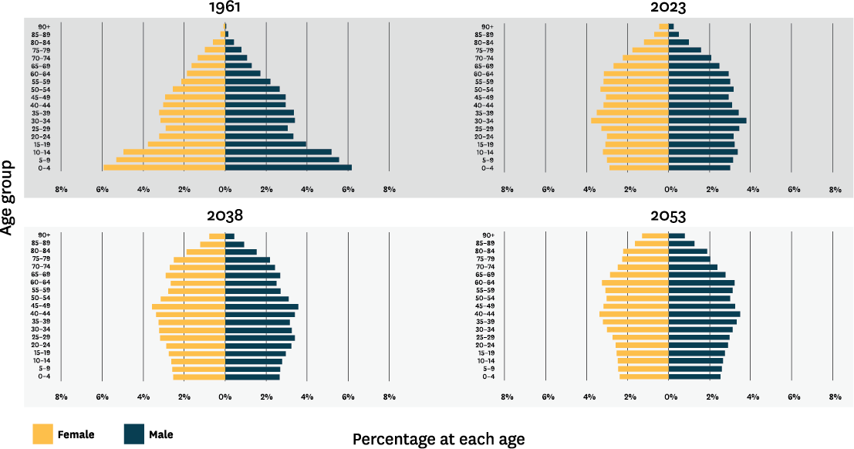
and older age groups in 2023, 2038 and 2053. These projections show that population ageing is not expected to be reversed.

FIGURE 2.1
Change in structure of Aotearoa New Zealand’s population age cohorts over time (Sources: Stats NZ, 1961 and Stats NZ, 2022)

As the population ages structurally, the absolute number of seniors will also increase. This is referred to as numerical ageing. Stats NZ Tatauranga Aotearoa
(Stats NZ) projects that the number of seniors will nearly double between 2023 and 2053 from around 850,000 (17 percent of the population) to around 1.5 million (24 percent of the population).

Te kanorau me te taupori kaumātuatanga

Ethnic diversity and population ageing
Compared to many societies, our population is marked by a great deal of ethnic diversity. Different ethnic groups are structurally ageing at different rates. This diversity puts us in a relatively unique position compared to other nations.
Figure 2.2 shows the population structures for Māori, Pacific peoples, Asian, and New Zealand European/ Other. Māori and Pacific peoples’ population structures have a younger profile, and it is probable that this
will continue through to 2043. However, the number of seniors is still expected to increase substantially, doubling for Māori in the decade to 2029.

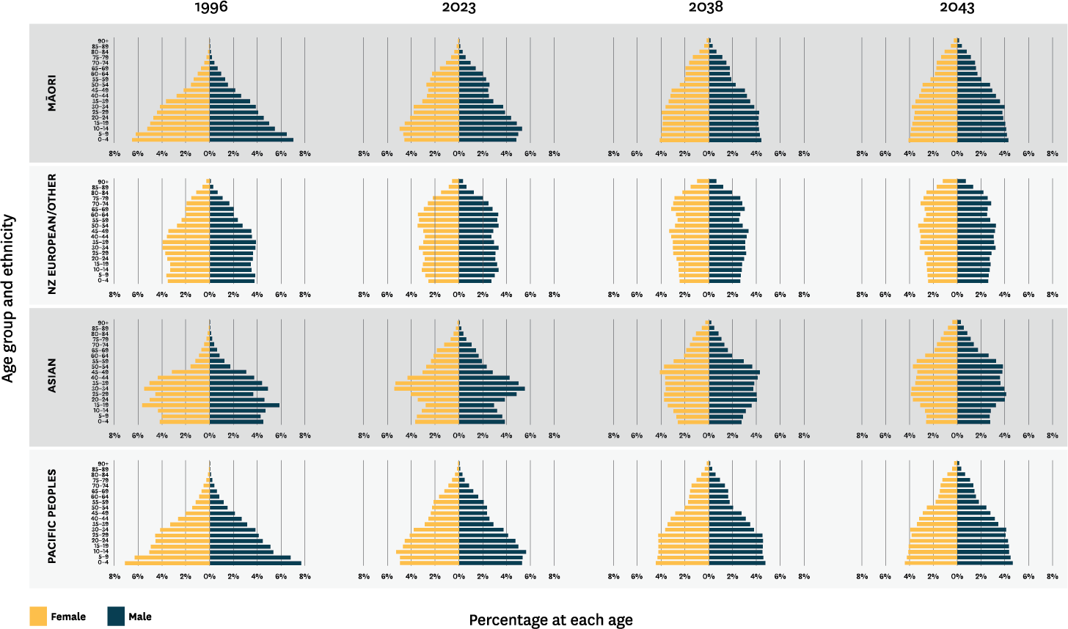

FIGURE 2.2
Change in structure of Aotearoa New Zealand’s population age cohorts over time, by ethnicity (Sources: Stats NZ, 2020 and Stats NZ, 2021)

Ngā rohe me te taupori kaumātuatanga

Regions and population ageing
While the proportion of seniors is projected to rise nationwide by over 8 percent between 2018 and 2048, this varies between regions. Some regions, such as Marlborough, currently have a high proportion of seniors (22.2 percent), but a relatively low number
of seniors (10,800). Other regions, like Auckland, have a young population structure with only 11.9 percent aged 65 years and older, but a substantial number of seniors (197,000) (Table 2.1).
These regional differences will be even more exaggerated in the future. For example, the senior population in the Tasman region will double, but the overall population will only increase by 18.5 percent (Table 2.1).

 |  | 2018 |  | 2048
Region |  | Proportion of people aged  65+ | Number of people aged  65+ |  | Proportion of people aged  65+ |  | Number of people aged  65+
Northland Region |  | 19.4% | 36,000 |  | 29.0% |  | 67,100
Auckland Region |  | 11.9% | 197,000 |  | 18.8% |  | 434,000
Waikato Region |  | 15.7% | 74,800 |  | 24.4% |  | 149,800
Bay of Plenty Region |  | 18.2% | 58,500 |  | 27.5% |  | 111,200
Gisborne Region |  | 15.2% | 7,500 |  | 24.3% |  | 13,400
Hawke's Bay Region |  | 18.0% | 31,000 |  | 27.4% |  | 55,300
Taranaki Region |  | 17.2% | 20,800 |  | 26.8% |  | 37,100
Manawatu-Wanganui Region |  | 17.7% | 43,800 |  | 27.2% |  | 75,300
Wellington Region |  | 14.1% | 74,200 |  | 23.2% |  | 141,900
Tasman Region |  | 20.7% | 11,200 |  | 35.8% |  | 22,900
Nelson Region |  | 19.0% | 10,000 |  | 32.6% |  | 19,000
Marlborough Region |  | 22.2% | 10,800 |  | 33.4% |  | 17,600
West Coast Region |  | 19.4% | 6,300 |  | 31.4% |  | 9,600
Canterbury Region |  | 15.8% | 98,200 |  | 23.7% |  | 184,600
Otago Region |  | 16.1% | 37,800 |  | 25.4% |  | 71,700
Southland Region |  | 16.7% | 16,800 |  | 25.9% |  | 28,000
New Zealand |  | 15.0% | 734,900 |  | 23.2% |  | 1,439,400

TABLE 2.1
Proportion and number of people aged 65 and over in 2018 and 2048, by region and overall Aotearoa New Zealand. (Source: Stats NZ, 2021 Subnational population projections: 2018 (base) - 2048)

Taupori kaumātuatanga, rahinga, nekehanga anō hoki

Population ageing, size, and movement
Policy, housing markets, and attachments to a place can have significant impacts on population movements and the profile of populations across different regions and over time. For Māori, promotion of urbanisation prompted movement away from rural rohe in the post- World War II period. That movement affected rural housing investment and led to a separation between kāinga and whare.
Today, we’re seeing an emerging movement of younger, urbanised Māori back to regional towns and rural
rohe. This is being driven by fewer opportunities for urban owner occupation, unaffordable housing costs, and attachment to rohe. These movements are likely to impact on the size and age structure of regional populations.
Population movement in Aotearoa New Zealand has seen slow population growth or decline because of regional migration and urbanisation. In the medium- term, it’s projected that some areas will experience population decline. For example, the populations of Waitomo, Ruapehu, Buller, Grey, Westland, and Gore districts are all projected to fall between 2018 and 2048 (Stats NZ, Subnational population projections, medium projection, 2018 base). In the long-term, the population of all our regions will likely peak and then fall.
Aotearoa New Zealand’s population has also experienced a strong northward drift, which has contributed to the growth of the Auckland population. The Auckland population has been sustained by Auckland acting as a gateway city to international migration and a younger population structure, despite net outward migration to other regions in recent years.
Population growth in Aotearoa New Zealand and globally will be affected by population ageing. With the proportion of the population of childbearing age falling and lower fertility levels, the world’s population will eventually peak and then decline.

3.

Taupori
kaumātuatanga me ngā anamata whanake whare, tāone anō hoki Ageing populations and housing and urban futures

Population ageing will exacerbate existing challenges for our housing and urban systems.
We consider this in the context of existing conditions in Aotearoa New Zealand and what that means for likely futures across the three domains. These are:

- Housing tenure and housing costs
- Our houses and our housing stock
- Neighbourhoods, towns, and cities.

Te rīhi whare me ngā utu whare

Housing tenure and housing costs
Housing tenure has changed over time Patterns of tenure, housing costs, and affordability have changed significantly over the last few decades. The number of people, as well as the proportion of our population entering their senior years as renters, is increasing significantly. There are also more children,
proportionately and in numbers, being raised in rentals. This raises questions about how people will meet their financial, social, cultural, and health needs across their life stages and into older age.
From the 1950s to the 1990s, the housing system supplied low-cost dwellings for owner occupation. This generated a pattern of tenure in which much of the population lived in owner-occupied dwellings. Rental housing was largely limited to people in transition, low- income families accessing state housing, or seniors in council housing who no longer, or had never, owned their own home. There were variations between different

ethnic groups, with Māori and Pacific peoples less likely to be in owner occupation. However, even for Māori and Pacific peoples, owner occupation was higher than it is now, at 54 percent and 51 percent respectively.
The impact of the shift in the housing system in the 1990s is evident in the tenure pattern found among different age cohorts.

- Of the cohort born between 1927-1931, 86 percent were in owner occupation by age 65.
- Of the cohort born 1942-1946, 85 percent were in owner occupation by age 45.
- Of the cohort born 1967-1971, 56 percent were in owner occupation by age 45.

Differences in housing tenure has affected some parts of the population differently Increased reliance on rental housing and reduced owner occupation is evident across all ethnicities. Māori and Pacific peoples are particularly impacted by declining owner occupation, although the pathways to this have been different.
Between 1986 and 2018, owner occupation for Māori fell from around 54 percent to 40 percent. By comparison, in 1986 around 79 percent of New Zealand Europeans were in owner occupation, declining to around 56 percent in 2018. For Pacific peoples, owner occupation fell from about 51 percent in 1986 to 31 percent in 2018.

The interface between housing policy and demographics are evident in the disparities in owner occupation and subsequent declines. The New Zealand European population was in its prime child-bearing and rearing years in the 1950s, 1960s and 1970s. They benefited from a housing system, housing policy, and government housing investment that stimulated the production of
low-cost houses and helped young families into owner occupation. Both Māori and Pacific population structures have only recently had an age profile similar to the European population of the 1950s, 1960s and 1970s.
However, the housing system does not invest in housing for young families in the way that it did between the 1950s and the housing reforms in the 1990s.
Māori housing experiences and outcomes have been defined by a complexity of factors including the
appropriation of land, difficulties in accessing business and housing finance, promotion of urbanisation and the associated deterioration in the rural housing
stock. In earlier decades, there were some innovative programmes critical to unlocking housing opportunities for Māori. Māori-led land development schemes under the Native Land Amendment and Native Land Claims Adjustment Act 1929, enabled 650,000 acres of land to be gazetted for development including housing, by 1935. Lending options were made available under the Native Housing Act 1935, for Māori to build, repair and improve their homes. However, lending limits for loans under the Native Housing Act were lower than those available through other options like ‘State Advances
loans’, and they were not eligible to be secured against freehold land.
As a consequence, Māori have not benefited as much from intergenerational wealth transfer through housing. Poorer housing outcomes and disparities between our New Zealand European and Māori populations are persistent and generate pressures on the wellbeing of future older people.

Wai 2750 is exploring the drivers of housing outcomes for Māori
The Waitangi Tribunal (the Tribunal) is currently undertaking a two-stage kaupapa inquiry (known as Wai 2750) to hear claims from Māori who have been affected by housing policy and services. The first stage of the inquiry focused on homelessness, with a report
and findings of this stage expected in 2023. The second stage of the Inquiry was announced in December 2022. In this stage, the Tribunal will hear all remaining claim issues within a single comprehensive inquiry advanced by theme. The Tribunal outlines the four themes as:
- Whenua Māori – Use and development of Māori land for housing.
- Te Ao Kāinga – Housing policy, practice, and regulation of the housing market.
- Whānau Kāinga – Social housing and the provision of ‘public housing’ by central and/or local government.
- Hauora – Relationship between poor physical and mental health (and other socio-economic factors) and housing.

All remaining issues in this inquiry will be reported on in a single comprehensive report to be released at the end of the inquiry.

Rising housing costs are increasing housing stress
Renters are spending a greater proportion of their income on housing costs than homeowners. Figure 3.1 shows that housing costs relative to incomes have increased for both renters and owner occupiers.
Housing stress started to affect households, and especially renters, from the 1990s. Severe housing stress (spending 50 percent or more of gross household income) was a minority experience. In 1995, for the first time, more than 10 percent of renting households were in severe housing stress.

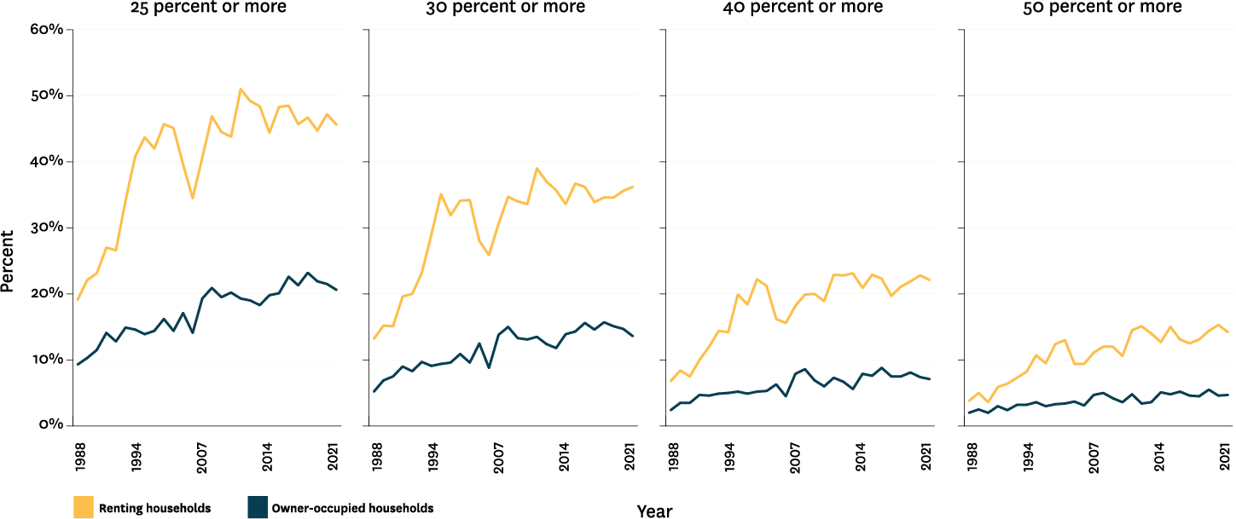

FIGURE 3.1
Proportion of households by housing costs to gross household income ratio (nominal), by tenure, year ended June 1988 – 2021 (Source: Stats NZ, Household Economic Survey)

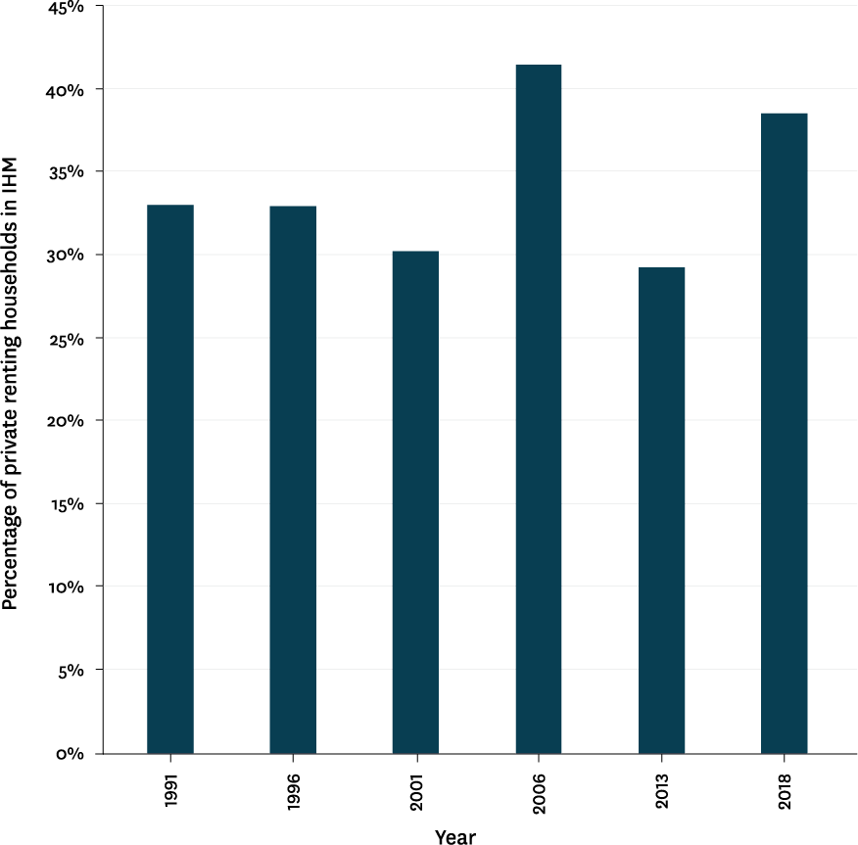
More renters are finding it difficult to save to buy their own home
There are an increasing proportion and number of households in paid employment who are in rental housing (Figure 3.2). These households are often referred to as the intermediate housing market (IHM). In 1991, 33 percent (83,330 working households) were in the IHM compared to around 39 percent (213,400 working households) in 2018.
Renting households with high rents relative to income find it difficult to save and their chances of entering owner occupation are likely to be reduced. This barrier to owner occupation grows as the price of entry level housing increases. This is usually measured as lower quartile value (Figure 3.3).

FIGURE 3.2
Proportion of private renting households in the Intermediate Housing Market 1991-2018 (Sources: CoreLogic, Stats NZ, HUD)

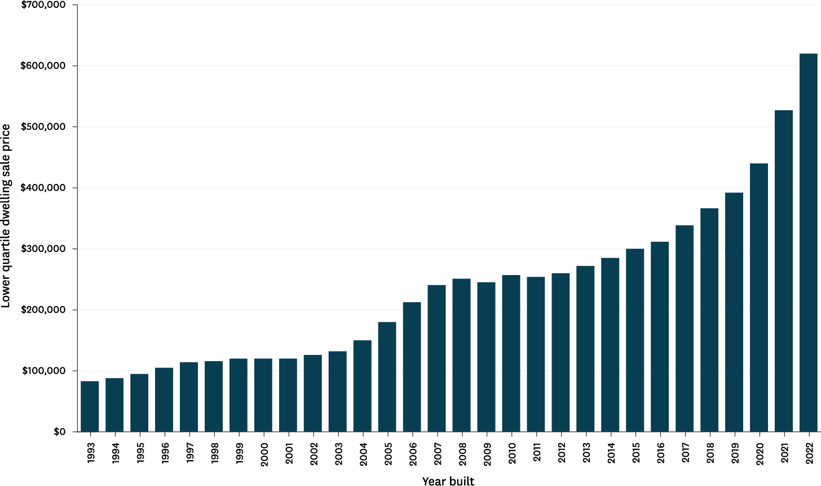

FIGURE 3.3
Lower quartile sales prices for residential dwellings, by year to 30 June (Source: CoreLogic Property Data)

These trends will have significant impacts on our ageing population
Declining owner occupation combined with an ageing population means that there is already a much more pronounced reliance of seniors of all ethnicities on rental housing. This includes Pacific peoples whose housing status was destabilised by the impacts of ‘Dawn Raids’ on Pacific young people in the early 1970s as well as changes in the labour market and housing policy.
There are likely to be significant effects:

- Increased pressure on retirement income support systems and the welfare system as seniors need greater income support for their housing costs.
- Less secure tenure resulting in increased financial costs, such as moving costs, and increased stress, negatively impacting wellbeing.
- New pressures on residential care and the residential care subsidy. Senior renters are likely to be assessed in need of residential care earlier than owner occupiers because they’re more likely to have poorer health. Senior renters are also more likely to be eligible for residential care subsidies due to low incomes and assets.
- Impacts on the retirement village sector. The sector depends on households being able to sell their homes, to free up capital to purchase retirement village occupation right agreements. It also relies on high levels of disposable income to spend on retirement village fees.
- Increasing housing disparity for subsequent generations as housing wealth becomes concentrated among fewer households, which is likely to further decrease rates of owner occupation.
The trend towards lower owner occupation means we need to consider housing tenure and affordability solutions beyond traditional renting or owner occupation, to more opportunities for intermediate
tenures. Intermediate tenures are those between owner occupation and renting, such as co-operatives and co- housing, shared equity co-ownership, deed-restricted housing, or papakāinga. They leverage household contributions with other partners to provide affordable capital to invest in dwellings. This provides affordable ongoing housing costs while providing secure tenure.
There are currently few alternative or ‘intermediate tenure dwellings’ that could provide for lower cost housing.
These types of intermediate tenures do exist in Aotearoa New Zealand but are not widely known or understood by households, professionals dealing with housing finance, people providing residential property legal advice, or the construction sector.
Papakāinga are an important element of the Māori housing system. Papakāinga developments, which are usually on collectively owned Māori land, generally
involve intergenerational living and may include specific kaumātua housing. However, the ability of iwi, hapū and Māori trusts to build papakāinga on Māori land is currently limited by difficulties in accessing finance, planning restrictions, and other longstanding barriers to building on whenua Māori that need to be addressed.

Ō tātou whare me te maha o ō tātou whare

Our houses and our housing stock
Our housing stock refers to the total number of houses or dwellings in Aotearoa New Zealand. Housing typologies range from detached houses to townhouses and high-rise apartments. The diversity of our housing stock, including the typologies and size of dwellings can impact
on whether households can find the dwellings that best fit their needs. Dwelling size can also impact on build costs, housing prices, the costs of maintenance and other outgoings, and carbon emissions.
There are around 1.8 million dwellings in Aotearoa New Zealand. Of these, around 80 percent are detached houses and semi-
detached townhouses, and around 20 percent are multi-unit flats and apartments.

Good housing and urban design can support us to be independent for longer Design characteristics affect how accessible and functional a dwelling is, and how well
it serves people across different life stages and with different capabilities. Appropriately designed dwellings allow people to optimise
their independence, mitigate the effects of compromised mobility, limited sight and hearing, cognitive issues including dementia, and better support people with disabilities.
The World Health Organization has recognised for over 20 years that good housing and urban design can push back the disability threshold. The disability threshold identifies an individual’s level of independence. When the disability threshold is crossed, a person is unable to live independently due to a decrease in functional capacity (Figure 3.4).

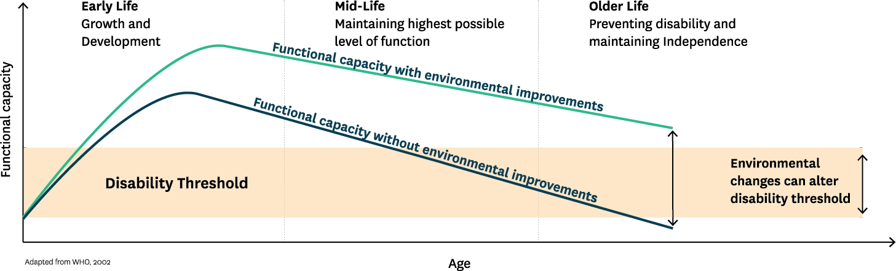
FIGURE 3.4
Functional capacity and the shifting disability threshold (Source: Adapted from World Health Organization, 2002)

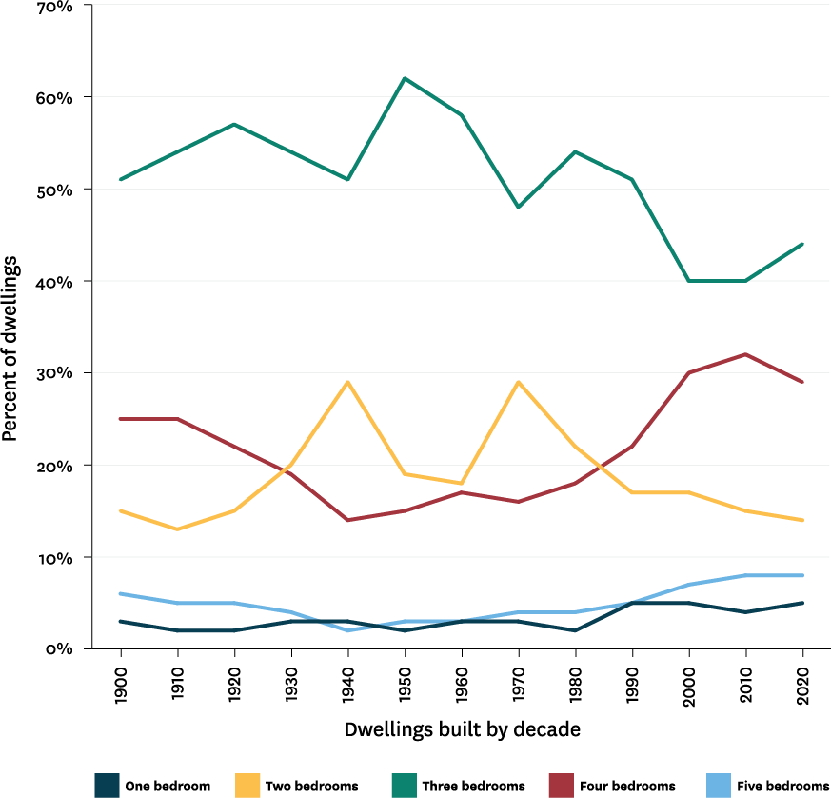
Population ageing intensifies two longstanding issues with our housing stock
The issues associated with our housing stock are:

- The dwellings in our housing stock do not respond well to changes in the range of household sizes needed. They also do not adapt to alternative forms of living
arrangements, including intergenerational living.
- Our existing (and many new build) dwellings are not designed or built to respond to changes in our functional capacity, including age- related frailty and the needs of disabled people throughout their life.

Dwelling size and household needs in an ageing population
An ageing and increasingly diverse population needs an increasingly diverse housing stock. However, our housing stock remains dominated by dwellings with three bedrooms (Figure 3.5).

FIGURE 3.5
Bedrooms as a percentage of dwellings built per decade (Sources: Councils District Valuation Rolls for decade data, HUD [CoreLogic and MBIE data for bedroom data])

Housing designed to be functional and accessible
As people age, their need for accessible dwellings increases. Living in an accessible home reduces the impact of age-related changes in functional capacity and means they can be independent for longer. Accessible dwellings also mitigate the additional impact of ageing with a disability on the independence of disabled people. In Aotearoa New Zealand, newly built functional and accessible dwellings are limited. The traditional approach has been largely focused on retrofitted modification to existing stock and limited commissioning of ‘special housing’ for some people with disabilities.
Apart from ensuring that seniors and people with disabilities can stay connected with their families, whānau, friends, and communities, overseas research demonstrates that accessible housing reduces the costs of in-home services and care and reduces or delays residential care provision (James et al., 2018; Scotts
et al., 2007). Research here in Aotearoa New Zealand suggests increasing dwelling accessibility reduces the rate of injuries caused by falls at home per year by 26 percent and provides a 33 percent reduction in the costs of home fall injuries (Keall et al., 2017).
Minor improvements in functionality can be achieved in existing housing to improve safety but major enablers of accessibility are best built into the design of new dwellings. These major enablers include:

- level entry
- door and corridor widths that allow use of aids such as walkers and wheelchairs
- functional door and window hardware and heights
- lever taps
- reachable light and power sockets
- accessible toilets and showers, and
- robust wall framing necessary for grab rails.
Modification of these elements in existing dwellings is often not affordable without financial assistance. Health sector or Accident Compensation Corporation funding directed at home modifications has demonstrated that retrofits tend to be expensive, limited in scope, and associated with long waiting times.
Evidence from Aotearoa New Zealand and overseas shows that new builds designed to be accessible and functional present only a minor marginal cost to build across most typologies. It was estimated in 2009 that by 2039, cost savings from installing universal design features in the construction of new dwellings, compared to retrofitting in future, amount to approximately $390 million in present value (Page and Curtis, 2011; James et al., 2018; Scotts et al., 2007; Saville-Smith et al., 2007; Rashbrook, 2009; James et al., 2018).

In 2009, it was estimated that to meet the needs of our changing population, we would have to build around 3,500 accessible dwellings in Aotearoa New Zealand every year by 2039. In 2018, it was estimated Aotearoa New Zealand needed to build 8,000 accessible homes every year for the next 10 years to make up the lack of accessible dwellings from the previous decade. More exploration is needed around approaches to typologies such as walk-ups and very small dwellings for designs that support adaptation, accessibility, and affordability, in the context of an ageing population and stresses within the construction industry.

Stock change, regulation, accreditation, and practices
Building legislation and regulation has prompted significant shifts in other aspects of building performance such as build practices, materials, design, and building management for more than a century (James et al., 2018).
Aotearoa New Zealand has an internationally recognised accreditation tool (LifeMark) to assist the construction industry to demonstrate accessibility and functionality of new builds. However, unlike Europe, the United Kingdom, North America, and Japan, residential housing is excluded from legislative requirements for accessibility in new builds.
Persistently low production of accessible new builds, despite a well-reputed accreditation system and an ageing population, is consistent with international experience and research. Where change has
been achieved, the research shows that legislative requirements are critical but are most effective when supported by other factors that increase understanding of the benefits, build capability, and smooth the transition costs. This can include:

- robust and transparent accreditation processes
- raising consumer knowledge and expectations
- investment in accessible builds, and
- incentives and supports for the construction industry to take up opportunities and make the transition
to delivering accessible and functional housing at affordable price points.

Dealing with housing stock inertia
Diversifying our housing stock by simply building more houses with one or two bedrooms will not necessarily meet the needs of an ageing population. We want housing stock that provides more housing choice, including a range of housing types, at a range of prices.
We need to enable people to remain independent in their own home for longer, and to have choices to downsize to a smaller dwelling in their existing neighbourhood if they want to.

1 Additional dwelling units are also known as minor household units, minor dwellings, and granny flats.
2 Partitioning of an existing dwelling is where a larger house is divided up to make two or more smaller dwellings. This can also include converting basements and attics and other spaces to be used as a dwelling.
Intergenerational living and extended families including seniors will require more large dwellings as well.
Additional dwelling units1 and partitioning of existing dwellings2 have potential to diversify the size of the stock within existing residential areas and using existing residential titles.
Changing our housing stock will take time. Even in periods of intensive construction, new builds will make up only a small proportion of our total stock, and it will take decades to achieve wide-spread change. As of 2020, around half (53.5 percent) of our housing stock was built in the last 40 years, with around a third built in the last 20 years.
Given that housing stock changes slowly, what we build now matters. There are a range of factors that impact on what is built:
- The construction industry plays a significant role through its design and build practices.
- Councils have a significant role in ensuring stock diversification through the way they enable and limit development through their Resource Management Act strategies, plans, and policies.
- Land banking by developers and other property owners may be contributing to how and when housing is developed.
- Residential covenants created by developers impose further requirements on the size, design, materials, and value of dwellings, even when alternatives are permitted under district planning rules. Covenants frequently exclude lower-cost housing and multi-unit and/or smaller dwellings. In some cases, they can require that features such as ramps are not included in designs.

Paekiritata, tāone, tāone nui anō hoki

Neighbourhoods, towns, and cities
Our neighbourhoods, towns, and cities play an important role in how we live, work, and play. Well-designed places can shift the disability threshold in the same way that well-designed dwellings can.
Like our housing stock, our towns, cities, and neighbourhoods have evolved over time. The built environments of our towns and cities today are a product of development patterns over many decades. For example, in our larger cities early growth was largely shaped by walking proximity and tram and rail networks. These early suburbs tend to still have many of the features needed to support older people. They are accessible, walkable, with good amenities and services.
Later on, most of our regional centres and the newer suburban neighbourhoods of our cities were shaped by the rise of cars and new motorway networks. Urban planning typically separated lower-density residential suburbs from areas of commercial and other activities. These places tend to be less accessible without a car, with services located further away. This makes our towns and cities increasingly ill-adapted to an ageing population.

3 Around 89 percent of 65- to 74-year-olds held a driver licence in 2014 compared to around 72 percent in 1990. For seniors over 75 years old, only 45 percent held a driver license in 1990, while 73 percent did by 2014.
Age-friendly towns, cities, and places that are designed to be friendly to children and young people as well as seniors, are recognised internationally as promoting participation in education, employment, and civic life.
The challenges for our places as our population ages will be significant:

- Seniors may have limited ability to drive and travel long distances. Although people are retaining their driver license longer into their senior years3, it is estimated that within the next twenty 20 years the number of seniors unable to drive will double and may reach around 300,000 people.
- More seniors are staying in paid work for longer and need to travel easily to employment or have access to employment close to their homes and in their communities.
- There will be an increasing number of seniors living in our towns, cities, and rural areas with an
associated increase in age-related frailties, including cognitive issues such as dementia.
The key to ensuring that our towns and cities cater well to our aging population is having walkable, connected neighbourhoods with easy access to key amenities, and streets that people with mobility, sensory and cognitive issues can navigate independently and safely. This has attracted increasing attention internationally. Creating age-friendly spaces can takes a range of forms, including those shown in Figure 3.6.

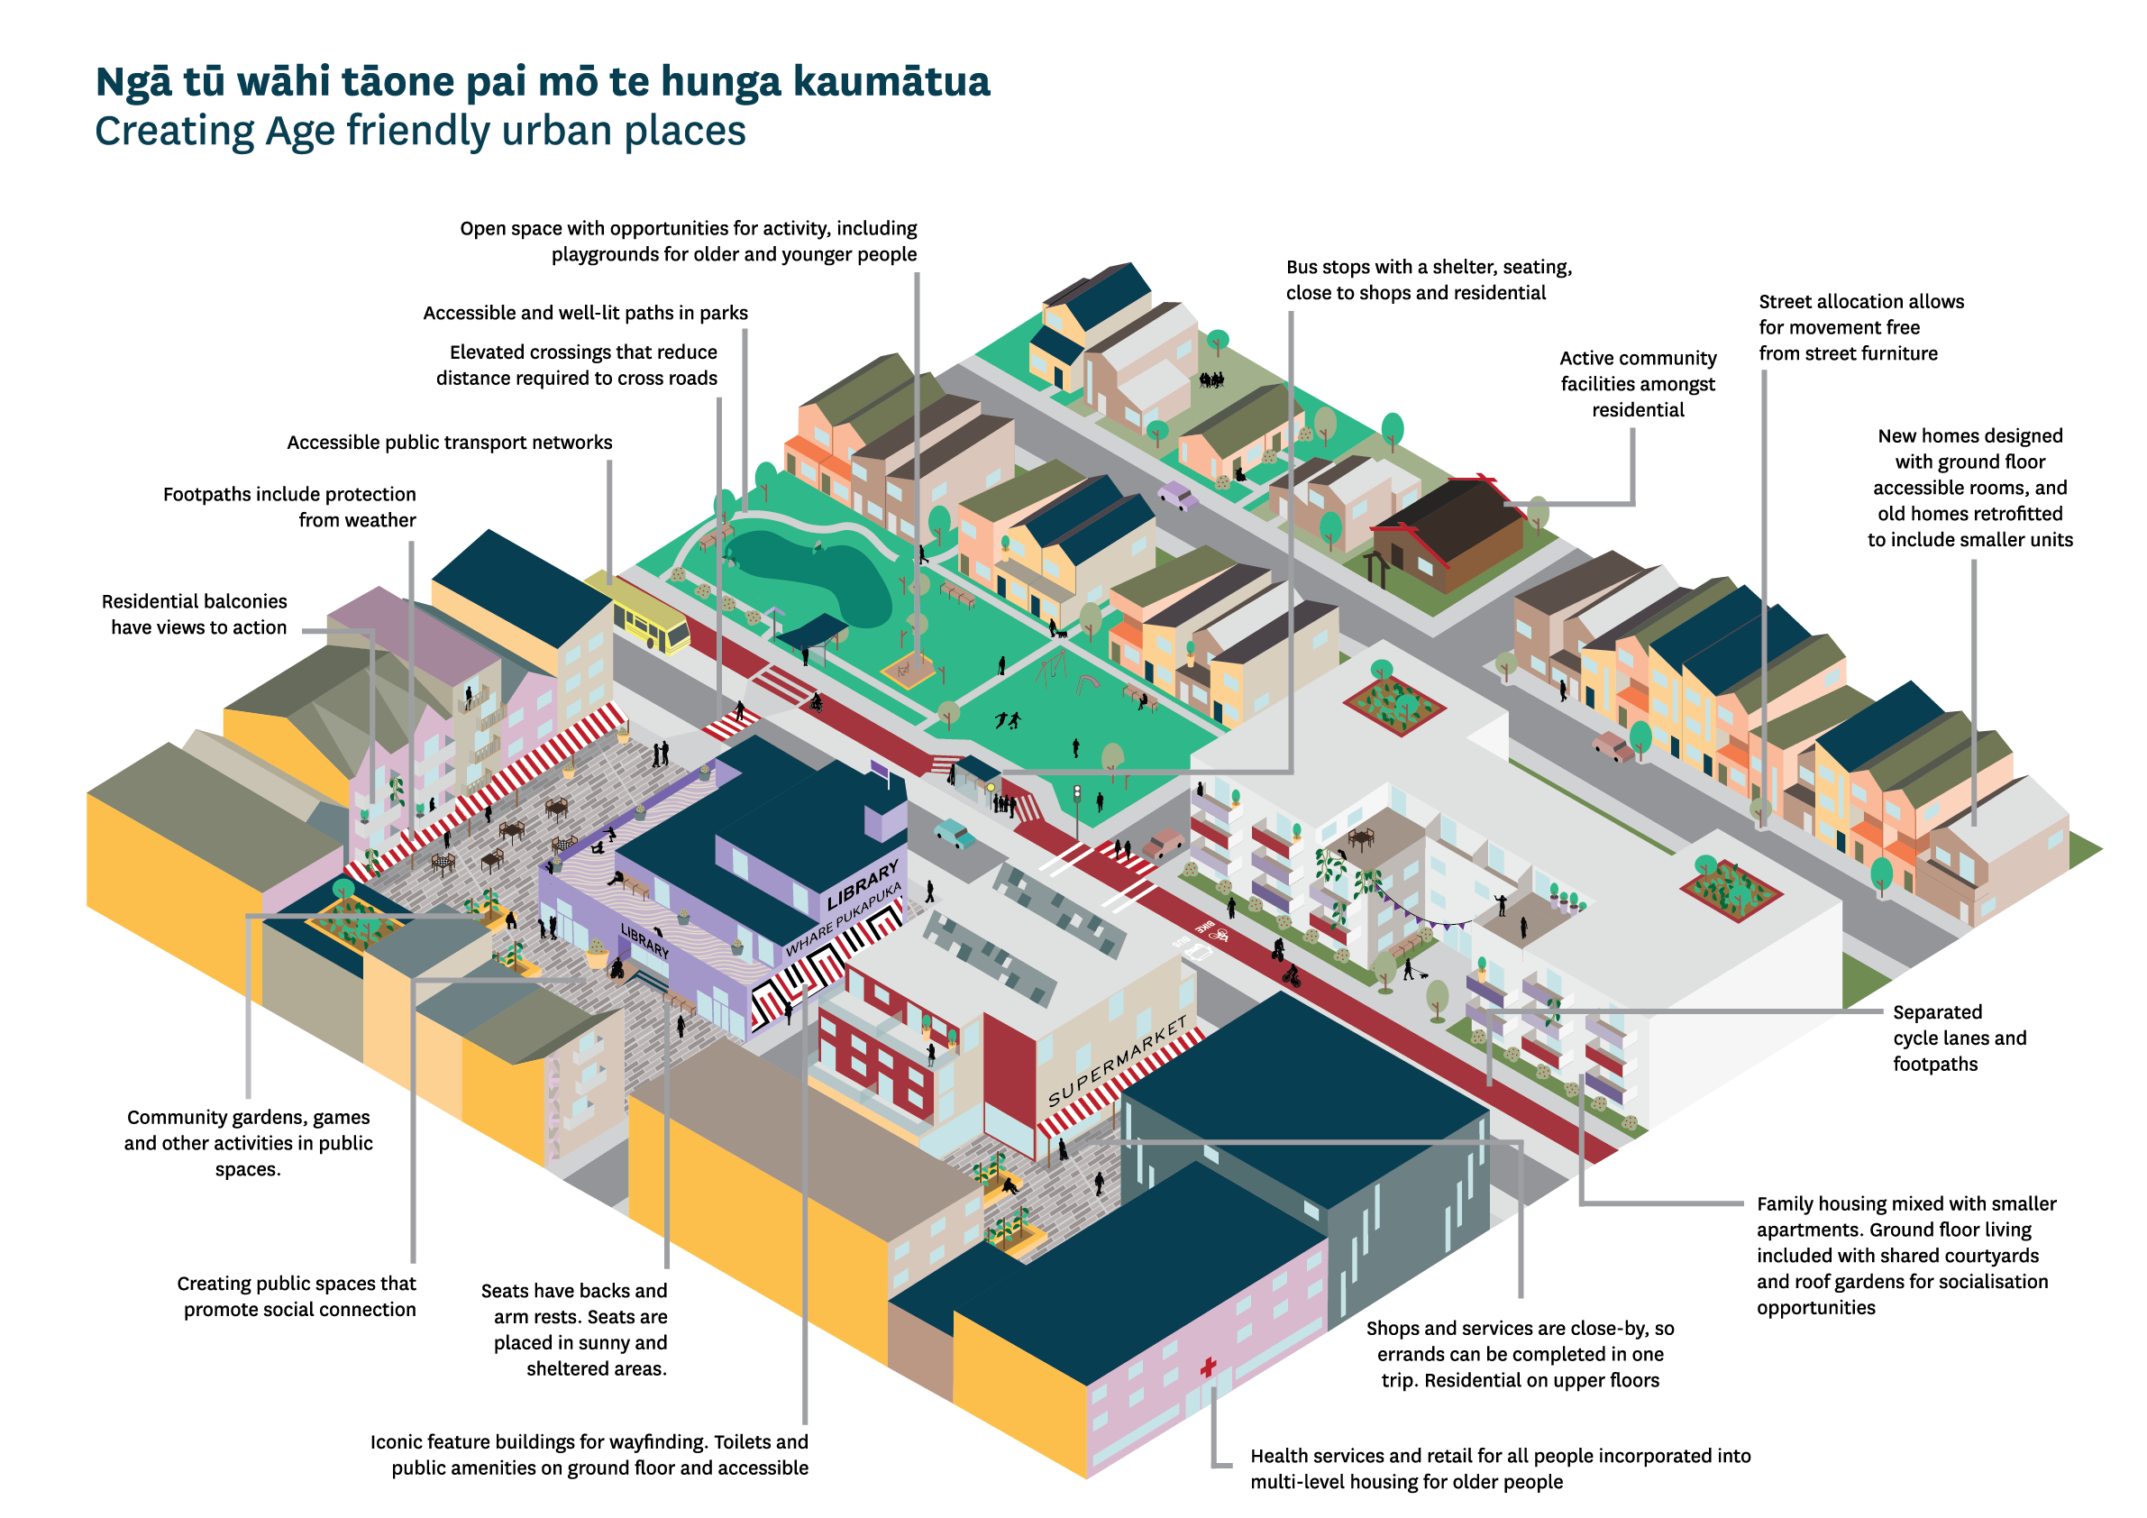

FIGURE 3.6
Creating age friendly places within towns and cities (Source: Office for Seniors, 2019)

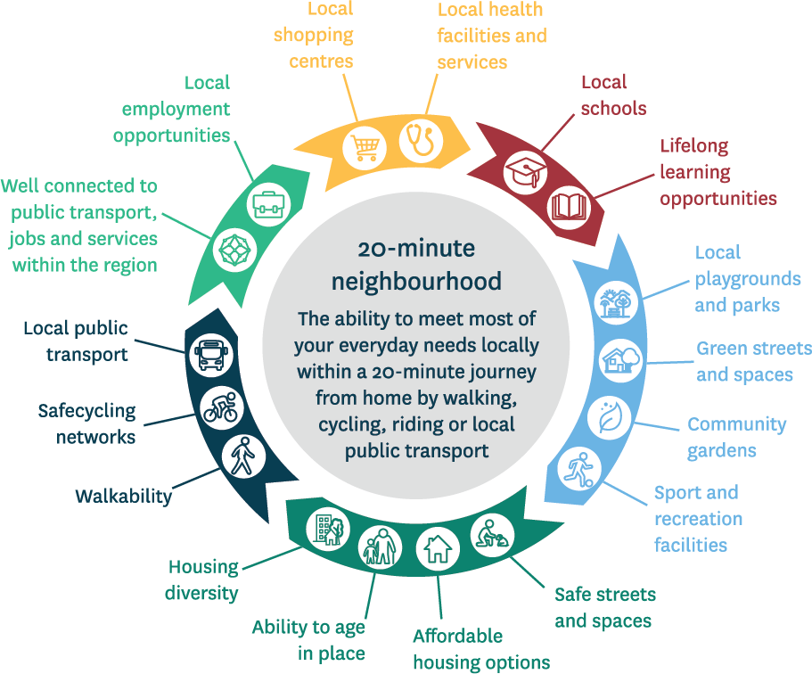
Many of the features of age- friendly, multi-functional and accessible neighbourhoods are shared with the ‘20-minute city’ concept in urban planning (Figure 3.7). This is where people can meet most of their everyday needs within a 20-minute journey from home by walking, cycling, or public transport.

FIGURE 3.7
20-minute cities or neighbourhoods should have access to these features. (Source: State of Victoria Department of Environment, Land, Water and Planning, Melbourne.)

Climate change and associated extreme weather, flooding, and coastal inundation presents challenges to towns, cities and urban areas. The movement of seniors to ‘sunshine belts’, early patterns of retirement village building, and the historical location of housing stock means seniors are over-represented among populations vulnerable to climate change. This raises issues around implementation of possible longer-term strategies such as managed retreat.
Climate change events and vulnerability to other natural adverse events such as earthquakes also raise issues regarding:

  - the affordability of, and access to, insurance for seniors typically on limited incomes
  - the provision and practices of emergency responses in the context of adverse events, and
  - the need for timely repair and maintenance of owner occupied and, particularly, rented dwellings that tend to be older and in less robust condition.
Population ageing may have implications for councils’ ability to fund and finance the infrastructure needed for housing and urban development, if the ability to raise rates is impacted by lower household incomes and slowing growth or even decline in the number
of households that pay rates. Notably, attenuated infrastructure associated with sprawl and low density that is not age friendly, is an expensive urban form to maintain, and very vulnerable in climate change adverse events and earthquakes. There has been
some argument that sprawled forms provide lower cost housing opportunities on the periphery of towns and cities. However, research on impacts on living costs, such as travel, discounts the benefits.

Te hīkina o te mānuka - kia ararau tā
4.
tātou urupare Meeting the challenge – we need a multi-faceted response
Aotearoa New Zealand’s population is ageing at a time where our housing and urban systems are already challenged.
Across these three domains, we've identified four key shifts needed for our housing and urban development system to support the needs of an ageing population across their life stages and into older age:

- More affordable housing. This will provide people with stability to participate in education, employment, and in their communities.
- Diversified tenure choices beyond renting and owner occupation to alternative tenures. This will improve tenure security, ensure housing costs are manageable, and sustain living standards to support wellbeing.
- Increased diversity and functionality of the housing stock. This will allow people to live as independently as possible.
- Neighbourhoods, towns, and cities that are designed to make it easy for people to access the amenities they need. This will support their wellbeing.
Exploring the impact of an ageing population on our housing and urban futures reinforces the need for
changes on a number of fronts, to ensure Aotearoa New Zealand has the homes and communities people need.
Some of the key elements that will need attention for the system to deliver homes and places that work well for an ageing population are:

- Stable and reliable funding of housing and infrastructure, to allow Kāinga Ora, CHPs, other not- for-profit organisations, and iwi and Māori to plan and support the development of diverse tenures and stock.
- Local planning and practices that:
- support age-friendly neighbourhoods
- enable intensification to better connect people, increase the cost-effectiveness and resilience of our infrastructure
- reduce the exposure of seniors and our housing stock to adverse natural events associated with climate change, such as flooding, coastal erosion, and coastal inundation
- enable people to find the housing typologies that best fits their needs within their communities
- support the building of housing that remains affordable, both to build and to operate over the life cycle of the dwelling
- support redevelopment, renovation, or replacement of inadequately performing existing stock
- better reflect Māori needs and aspirations, including enabling papakāinga on whenua Māori.

  - Effective use of suitable land for residential development, reducing land banking and private residential covenants that generate cost and other exclusionary barriers.
  - Removing barriers to the development of papakāinga and building on whenua Māori and multiply-owned land.
  - Working with the construction sector to support a transition to an industry that can deliver diverse housing that is accessible and functional, at affordable price points.
We need place-based solutions. While national funding and regulatory settings are important, there is no ‘one size fits all’ approach to supporting age-
friendly places. The mix of housing needed and design of neighbourhoods will differ from place to place. It
will depend on many factors, including the economy, geography, and the size, age, and ethnic mix of the population.
While we have work programmes underway that will address many of the factors above, a sustained and collaborative effort by central and local government, iwi and Māori, and the private and not-for-profit sectors will be needed to ensure that our places develop in ways that best meets the needs of an aging population.

Ngā tāpaetanga mō te tuhinga uiui Submissions on the Briefing consultation document
5.

In October 2022, we released a consultation document on our Briefing that focused on three key domains:
- Housing tenure and housing costs
- Our houses and our housing stock
- Neighbourhoods, towns, and cities.
It was informed by a research literature review conducted by Bedford Consulting Services Ltd. in 2021, available on the HUD website:
www.hud.govt.nz/our-work/long-term-insights-briefing
Consultation was open for feedback between 20 October and 10 November 2022. We received 25 submissions, including five from individual members of the public and 20 from a various sectors and interest groups (Table 5.1)4
Submitters confirmed that focusing on the impacts of an ageing population on our housing and urban futures was critical. They agreed with the three domains presented in the document.
Many submitters highlighted or elaborated on aspects of the material presented. Broadly, submissions focused on:
- Housing outcomes and wellbeing, including:
- How housing outcomes are likely to vary across regions, including the possibility of de-population in some areas in the medium term.
- How access to decent housing shapes life chances for children and young people, including their wellbeing and housing security in later life.
- Issues of intergenerational wealth transfer through home ownership and how that impacts on the wellbeing of families and whānau.
- The positive contribution that seniors make to society and the importance of ensuring people have the choice to age in the communities where they have lived.
- Tenure choices, including alternatives to renting and owner occupation, as ways of providing both improved housing security and housing affordability. There was a heavy emphasis on what was seen as the increasing insecurity of current seniors’ housing, especially among renters.
- Human rights, addressing housing disparities, and various ways of increasing protections for seniors

4 Respondents could select more than one
Sector |  | Number of submissions
Academia/Research |  | 3
Advocacy/Peak Body groups |  | 3
Building, construction, and development |  | 3
Central government |  | 4
Education |  | 2
Health |  | 3
Housing provider |  | 3
Iwi or Māori individual and/or organisation |  | 3
Property management |  | 1
Social support services provider |  | 3

sector they or their organisation represented,
who rent, including rent caps, further controls on rent

therefore the total number of responses to this question exceeds the number of submissions received.
TABLE 5.1
Number of Briefing consultation document submissions, by sector.
reviews and rental prices, eviction processes, and terms of lease.

  - Lifetime accessible and functional housing, including the challenges of adapting existing housing and support for legislative change to require provision of all or some portion of new-builds are accessible.
  - How to ensure the residential construction industry is supported to deliver accessible housing in the current context of price pressures, fears of reduced demand, and increased uncertainty.
  - Affordable housing supply, including:
    - How the housing and urban systems will generate affordable housing for increasing numbers of seniors with low incomes, which are liveable and connected to services and amenities.
    - Ensuring seniors’ housing provides enough space for home-based activities, or to accommodate
a caregiver, or visits from family, friends, and whānau.
  - Barriers to good housing and urban futures, including:
    - Council planning and decision-making processes, particularly around housing density, zoning, intergenerational living, retrofit alternatives such as partitioning existing large dwellings, and provisions for accessory dwelling units.
    - The need to deal with practises that compromise housing fairness, lack of housing stock diversity, and residential covenants. This relates to covenants that require specific house sizes and designs that tend to increase prices and reduce accessibility.
    - Lack of responsiveness to changing needs and a lack of culturally appropriate housing.
- A need for our neighbourhoods, towns, and cities to enable independent living and social connections to reduce isolation and loneliness, and to meet
everyday needs, such as access to transport, social and health services, and community participation.

Ngā mihi

Acknowledgements

We would like to acknowledge the people and organisations that have helped us develop our first Briefing.
We thank those who submitted as a part of our public consultation, and whose constructive feedback informed the final Briefing.
We acknowledge the range of demographers, researchers, sector representatives and experts in their fields from across Aotearoa New Zealand who have informed the development of our Briefing. This
helped us to better understand the range of interactions and implications across our three domains, and for different populations. Organisations that contributed include Office for Seniors/Te Tari Kaumātua, Abbeyfield New Zealand, LGNZ (Local Government New Zealand), Community Housing Aotearoa/Ngā Wharerau o Aotearoa, Te Ngira: Institute for Population Research, Nelson City Council, Ministry of Social Development, Positive Capital and Community Finance, Registered Master Builders Association, Manatū Hauora, Katoa Ltd., Accessible Properties, and Lifemark (a division of CCS Disability Action).
We also want to extend a special thanks to our Reference Group members, Shamubeel Eaqub (Economist, Sense Partners), Dr Natalie Jackson (Demographer Research Associate, Te Ngira: Institute for Population Research), and Professor Iain White (Environmental Planning, University of Waikato), for their input and feedback at critical points in the Briefing’s development.

Hei whakamōhiotanga

Disclaimer

HUD are the authors of the Briefing and remain solely responsible for the Briefing’s content.
The information in this publication is, according to the HUD’s best efforts, accurate at the time of publication. HUD will make every reasonable effort to keep it current and accurate. However, users of this publication are advised that:

- The information does not alter the laws of New Zealand, other official guidelines, or requirements.
- It does not constitute legal advice, and users should take specific advice from qualified professionals before taking any action based on information in this publication.
- HUD does not accept any responsibility or liability whatsoever whether in contract, tort, equity, or otherwise for any action taken as a result of reading, or reliance placed on this publication because of having read any part, or all, of the information in this publication or for any error, or inadequacy, deficiency, flaw in, or omission from the information in this publication.
- All references to websites, organisations, or people not within HUD are for convenience only and should not be taken as endorsement of those websites
or information contained in those websites nor of organisations or people referred to.
This document may be cited as: Te Tūāpapa Kura Kāinga – Ministry of Housing and Urban Development. 2023. The long-term implications of our ageing population for our housing and urban futures.
Wellington: Te Tūāpapa Kura Kāinga – Ministry of Housing and Urban Development.
Print: ISSN 2816-0517
Online: ISSN 2816-0525
Published in March 2023
Te Tūāpapa Kura Kāinga – Ministry of Housing and Urban Development
PO Box 82, Wellington 6140, New Zealand This document is available on our website:
www.hud.govt.nz/our-work/long-term-insights-briefing

© Crown copyright New Zealand 2023
The material contained in this report is subject to Crown copyright protection unless otherwise indicated. The Crown copyright protected material may be reproduced free of charge in any format or media without requiring specific permission. This is subject to the material being reproduced accurately and not being used in a derogatory manner or in a misleading context. Where the material is being published or issued
to others, the source and copyright status should be acknowledged. The permission to reproduce Crown copyright protected material does not extend to any material in this report that is identified as being the
copyright of a third party. Authorisation to reproduce such material should
be obtained from the copyright holders.

Ngā tohutoro i tipakohia

Selected references

This Briefing was informed by data and information from several sources. A number of those are referenced in the figures and tables. A
research literature review that was conducted by Bedford Consulting Services Ltd. in 2021, also contains a wide range of relevant references. This is available on our website:
www.hud.govt.nz/our-work/ long-term-insights-briefing/
The selected references in this section are those that readers may not be familiar with or have easy access to.
James, B., Saville-Smith, N., Saville-Smith, K., and Isaacs, N. (2018). Doing Better in Residential
Dwellings: Going Beyond the Code in Energy and Accessibility Performance (ER27 LR0508). BRANZ.

Keall, M., Pierse, N., Howden Chapman, P., Guria, J., Cunningham, C., and Baker, M. (2017). Cost benefit analysis of fall injuries prevented by
a programme of home modifications:
A cluster randomised control
trial. Injury Prevention: Journal of the International Society for Child and Adolescent Injury Prevention, 23
(1), 22 – 26.

Page, I. and Curtis, M.
(2011). Lifetime Housing – the Value Case (SR 263). BRANZ.

Pledger, M., Dunn, P., McDonald, J., Cumming, J., & Saville-Smith, K. (2020). Is the use of health services by older adults in New Zealand associated with their housing tenure? New Zealand Medical Journal, 135(1510), 23 – 34.

Pledger M., McDonald J., Dunn P., Cumming J., & Saville-Smith
K. (2019). The health of older New Zealanders in relation to housing tenure: Analysis of pooled data from three consecutive, annual New Zealand Health
Surveys. Australian and New Zealand Journal of Public Health, 43(2), 182
– 189.

Rashbrooke, G. (2009). Economic effects of utilising LifeMark at a national level. Report for the Ministry of Social Development.

Saville-Smith, K. and Saville, J. (2012). Getting Accessible Housing: Practical Approaches to Encouraging Industry Take-up and Meeting
Need. Report for Office for Disability Issues, and the Ministry of Business, Innovation and Employment.

Saville-Smith, K., James, B., Fraser, R., Ryan, B. and Travaglia, S.
(2007). Housing and Disability: Future Proofing New Zealand’s Housing Stock for an inclusive society.Centre for Housing Research Aotearoa
New Zealand.

Saville-Smith, K., James, B., Warren, J., and Coleman, A. (2009). Older People’s Housing Futures in 2050: Three scenarios for an ageing society. Centre for Housing Research Aotearoa New Zealand.

Scotts, M., Saville-Smith, K., and James, B. (2007). International trends in Accessible Housing for People with Disabilities. Working Paper 2. Centre for Housing Research Aotearoa
New Zealand.

